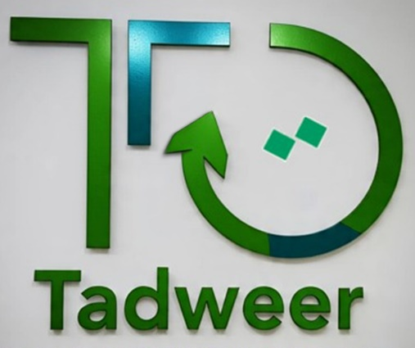

About us:
♻️🌿👉A new project to find a cleaner Syrian environment where waste is minimized, material is recycled, and communities live in harmony with nature.

Slogan:
- We give value to your garbage.
- Seeking a waste-free environment.
- We work together for your waste.
- Today’s waste, tomorrow’s energy.

Overview:
We are an initiative aiming to find solutions to the waste problem and to minimize its harm on the Syrian environment.

Our vision
To find a Syrian environment where waste is minimized, material is recycled, and communities live in harmony with nature.

Our goals:
We aim to create a movement where responsible consumption and recycling become a way of life for all Syrians, ensuring a cleaner, greener environment for future generations, by:
- Working on utilizing and recycling waste, and the generated energy from it.
- Working with the responsible authorities to develop a comprehensive waste-management plan.
- Pressuring decision-makers to enact legal regulations that ensure a better environment for the community.
- Working to change collective behavior within the Syrian society to improve waste management and sorting through awareness-raising workshops and sessions.
- Working to ensure environmental security for all members of Syrian society.

Mission Statement:
To promote a sustainable future by encouraging recyclability and reducing waste through education, innovation, and community engagement.
To collaborate with individuals, businesses, and governments by adopting eco-friendly practices, reducing landfill waste, and creating a circular economy where resources are reused, repurposed, and recycled efficiently.
Furthermore, to support youth engagement by creating green opportunities for them that enhance environmental quality.

Vision Statement:
A world where waste is minimized, every material is recyclable, and communities thrive in harmony with nature. We envision a global movement where responsible consumption and recycling become a way of life, ensuring a cleaner, greener planet for future generations.

Reviewed

